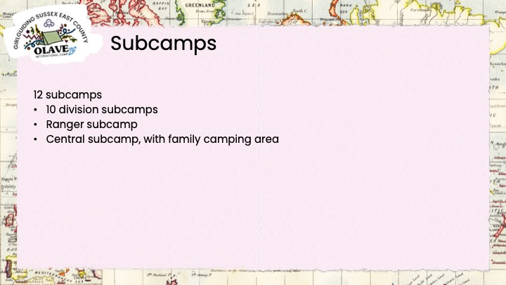
Subcamps to name themselves, based on the explore theme. Let me know as soon as you decide, so we don’t have duplicates.

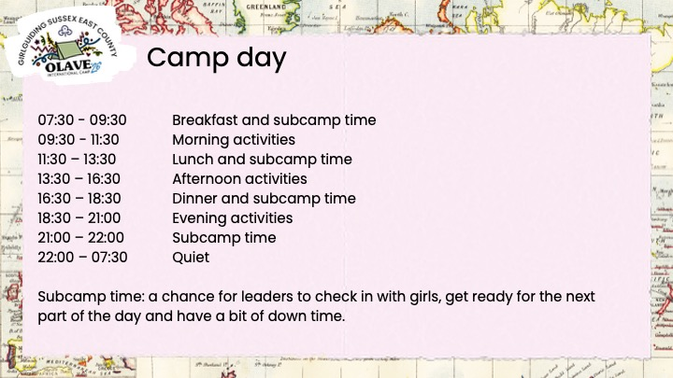
What is subcamp time? We know Olave is a very busy week and can sometimes be a bit full on and that a week at camp will be quite a challenge for some.

We’ve allocated two hours for each meal time to include subcamp time to slow the pace down a little. To allow time to get organised for activities, fill up water bottles without having to rush and hurry, and hopefully allow some time to sit down and relax for a bit.

There may be some exceptions and activities that don’t quite fit those times, particularly the Blackland activities, but for most that’s what we are working towards.

Meal times will be staggered and subcamps will be given a timeslot within the 2-hour window.

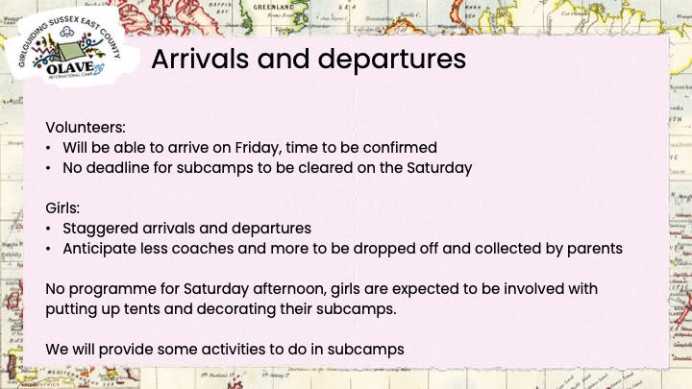

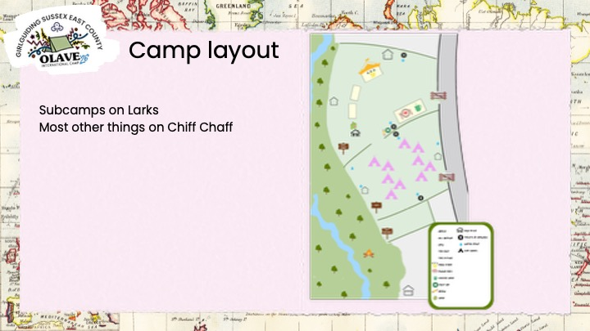
We also have Nuthatches for one of the activity zones.

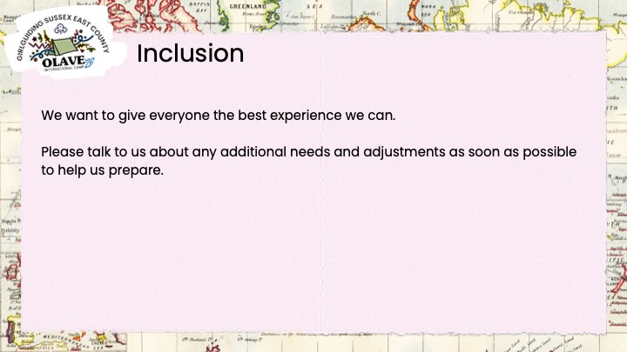
We don’t need full, completed adjustment plans right now but we do need an idea of what is required so we can make sure we are prepared.

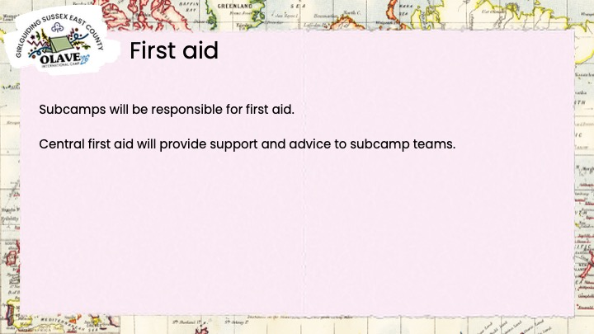

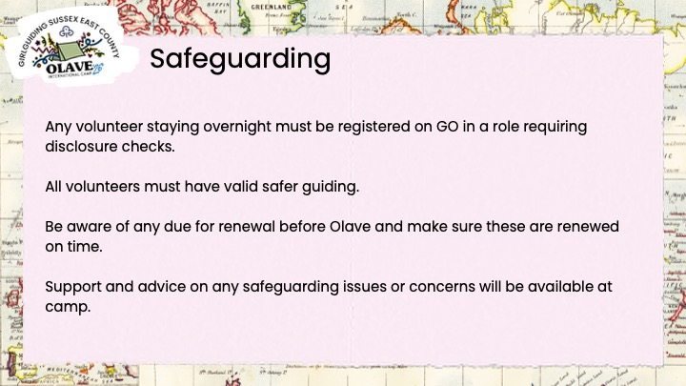

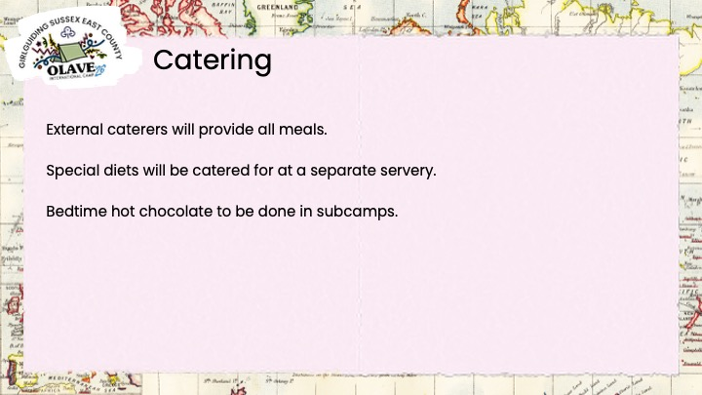
There will be a coffee and tuck shop, the Wanderers Rest. and a bar, the Map and Compass.

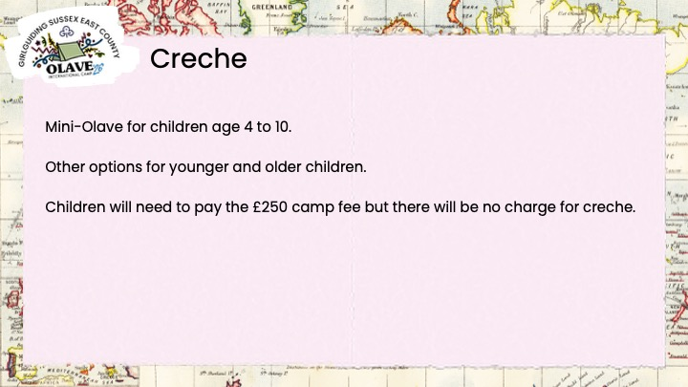
Details and registration forms for the creche will be sent to volunteers who have requested details. If there is anyone else who needs the details please let us know.

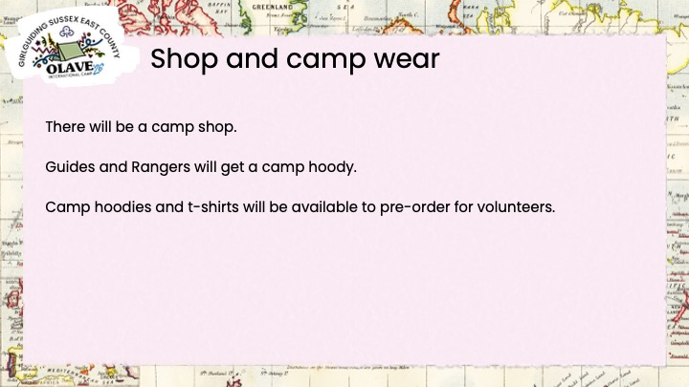

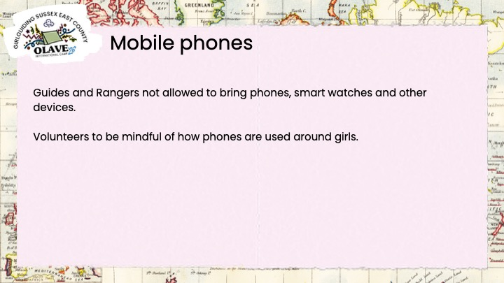

We know that there are mixed opinions about Guides and Rangers having mobile phones. We have talked, at length, about the pros and cons of this and decided that Guides and Rangers will not be allowed to bring phones, smart watches and devices to camp. There will of course, have to be some exceptions to this, for girls who need them to monitor medical conditions, such as diabetes, and we’ll need to make sure these are used, stored and charged appropriately.

Information for girls and parents explaining this decision will be shared with the kit list.

We ask that adults be considerate of their use of phones around the girls and are discrete when making calls, messaging, etc.

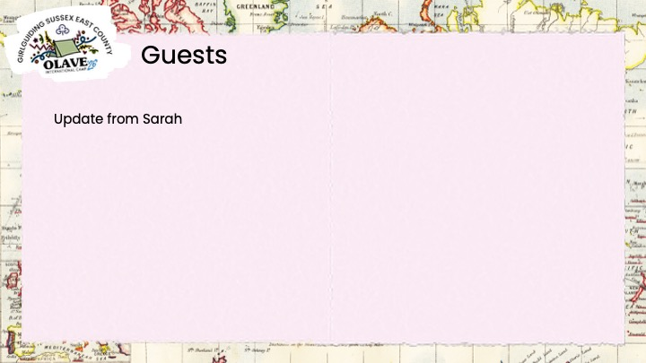
So far groups and volunteers from other areas of the UK and Canada, and expressions of interest from Japan.

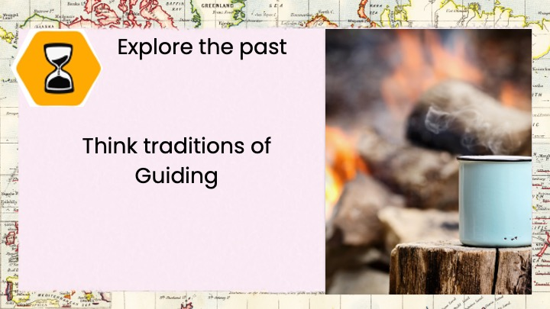

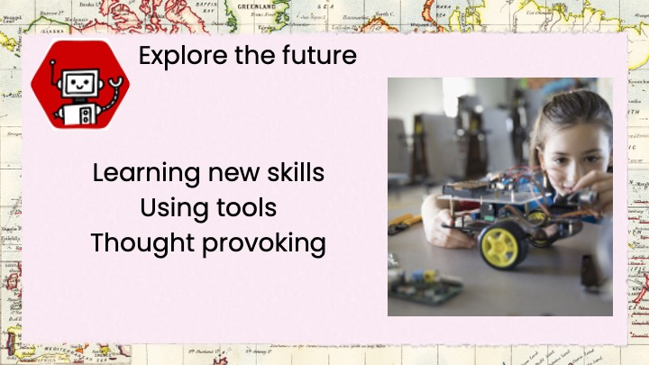

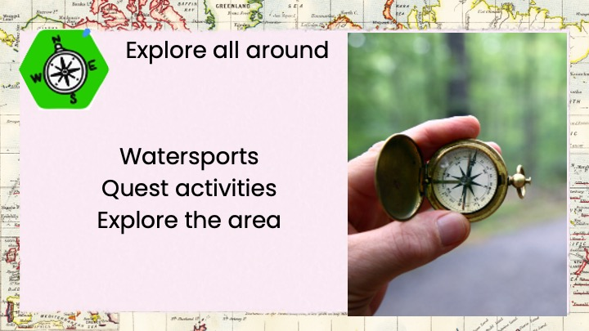

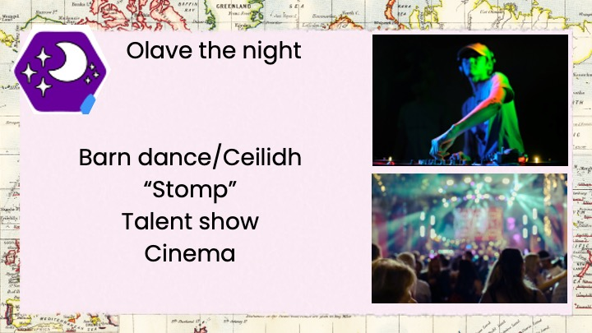

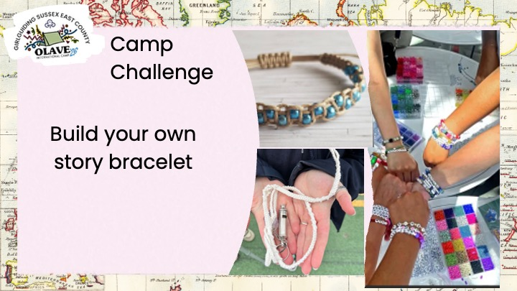

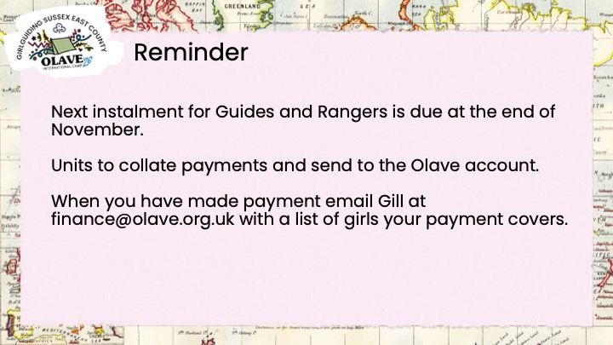

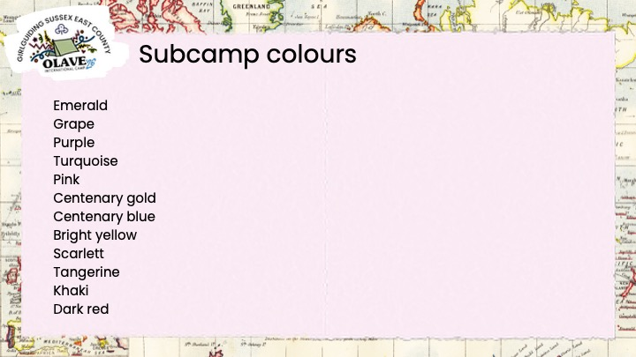

Emerald - Rangers
Grape - Lewes
Purple - Hastings
Turquoise - Weald
Pink - Central
Centenary gold - Eastbourne
Centenary blue – Brighton East
Bright yellow - Hove
Scarlet - Rother & Rother
Tangerine – Brighton West
Khaki - Seahaven
Dark red – St Leonards

QUESTIONS

How many girls are reregistered so far?
-As of this morning (8 Nov), 376 girls and 149 volunteers.

Will the girls money be cash only?
-We are planning to have cash and card payment options.

Is this big top returning?
-No, this was ruled out because of cost but there will be a main event tent.

Will Olave be sending a payment reminder to parents on should units do this?
-Olave will not be sending reminders. We know many units are fundraising towards costs and will not be asking for the full amount. We don’t want to cause confusion with conflicting messaging asking for different amounts.

Can the girls bring digital cameras?
-Yes, but please no power banks or portable chargers. There are risks with storing these in hot tents.

Is anyone dressing up as Winnie the Pooh with a pot of honey?
-No plans for this. Any volunteers?

Will subcamps be linked in advance with other international groups?
-Visiting groups tend to be quite last minute confirming books so this may not be possible.

Please can we order camp sweatshirts, rather than hoodies.
-We will look into options for this, it should be possible.

Will there be badges to collect for each programme zone?
-This was considered but is not currently planned, it was felt the cost of so many badges would take too much away from the programme budget.

Can ‘shift’ volunteers do overnights, ie two days and one night?
-Yes, volunteers can do the full week, or any combination of days and nights. Contact Carolyn, admin@olave.org.uk and she can advise on cost.

Are we (volunteers) to use our phones for photos?
-We know girls and their parents like to see photos from camp and hope volunteers will use their phones to take and share photos.

Catering questions

Are biscuits/snack/fruit to be supplied to subcamp?
-Snack will be provided, but likely to be distributed to activity zones so they are available to girls between mealtimes when girls won’t be at their subcamp.

Programme themed questions

Who is open day for?
-Rainbows, Brownies, Guides, Rangers, Volunteers and Trefoil.

Is the open day themed and do we need to plan something as a subcamp activity or stall like before?
-The open day will be Explore! themed as much as possible. Details of the open day are to be confirmed but we expect that subcamps will be asked to run an activity or stall as before. We hope to confirm details for the open day before the end of the year.

Will Rangers follow the same programme or is it completely different?
-The Ranger programme will be based on the same theme and zones, there will be some activities the same as Guides and others that are different.

Will Rangers on Division subcamps follow the Ranger programme?
-No. The option for Rangers is to stay on Division subcamp and follow the Guide programme. Or stay on Ranger subcamp and follow the Ranger programme.

Can I take a Leader and Ranger optional early morning run, on site?
-Yes.

