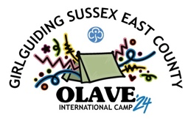 UK and international guests - register your interest

Olave 2024 will be from Saturday 27 July to Saturday 3 August 2024.

This will be a fun and exciting week at camp with Guides and Rangers from across Sussex East, with guests from the rest of the UK and around the World!

Cost and payments
The cost for participants is £380 and £100 for volunteers.
- Deposit of £80 (£50 for volunteers) to secure a place.
- Balance by 31 March 2024.

The deposit will be non-refundable from 30 September 2023. Remaining payments will be non-refundable from 30 April 2024.

How to book
Please complete and return this form to let us know that you are interested in joining us at Olave 2024. When you are ready to book, please complete and return the booking forms and deposit. Booking forms and payment details will be available with the information for guests on our website, olave2024.org.uk

Leaders wishing to volunteer do not need to register an interest, just complete the volunteer booking form available with the information for guests on our website, olave2024.org.uk

Return this form or send any questions you may have to guests@olave2024.org.uk

Group details
Group name
Where are you from?
UK groups - county and region or country
International groups - country
Estimated groups size  Minimum ratio of 1:12, and at least two adults | Participants  Leaders
Age range of participants

Group leader’s details
Leader’s name
Email address

