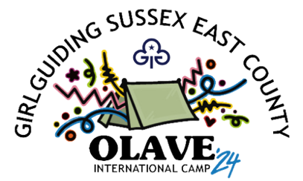 Olave 2024 guest booking form - volunteer

We’re really excited that you are going to join us at Olave 2024.

Cost and payments
The cost for volunteers is £100.
- Deposit of £50 to secure your place.
- Balance of £50 by 31 March 2024.

Volunteer cost includes all meals, a necker and a badge. It does not include a hoody, but these will be available to pre-order.
The deadline for applications is 31 March 2024. Deposits will be non-refundable after 30 September 2023 and balance non-refundable after 30 April 2024.

How to send payments
Payments can be made by BACS to: Girlguiding Sussex East re Olave 2024, sort code 20 27 94 and account number 43385949, SWIFTBIC BUKBGB22, and IBAN GB78 BUKB 2027 9443 3859 49.

If you have any questions about payments, contact payments@olave2024.org.uk

Returning your form
Send your forms by email to guests@olave2024.org.uk. If you would prefer to send them by post, contact us for the address.If you are a group Leader bringing girls to camp, please make sure you complete a group booking form, and individual volunteer and participant forms for each member of your group.
✂ - - - ✂ - - - Please cut and send the below section as detailed above - - - ✂ - - - ✂

Volunteer details
Name
Group (County / Country)
Email, - this will be used to share information about camp.

By signing this you are giving your consent to store your details on the Olave 24 booking system.

The system is password protected and details will only be used for the purposes of the camp, and to cover insurance and first aid. All personal details will be destroyed and deleted after camp.

This system is provided by Scouts EMS, their privacy policy can be viewed at https://www.scouts-ems.com/privacy-policy/ No personal data from Girlguiding information systems will be transferred to the Olave 24 booking system.
Signed: | Name:
Date:

If you are not part of group bringing girls and want a central role, which teams would you be interested in joining? Please circle all that you would be happy to join:
Admin | Dining room | First aid | Olave shop
Catering | Media | Programme | Tuck shop
Coffee shop | Site | Safety and security | Hygiene

